**Welcome to the**

**Bureau of Environmental Services**

**Treatment and Pumping System Division**

Our mission is to plan and implement projects using technical and engineering expertise to support the Operations and Maintenance Group in the management of risks at the bureau’s wastewater assets.

November 2023

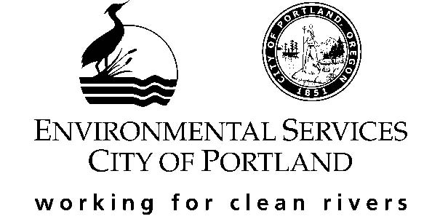

These materials are provided to help orient you to the bureau, the group, and your new job. Please take the necessary time to review the material and feel free to ask questions.

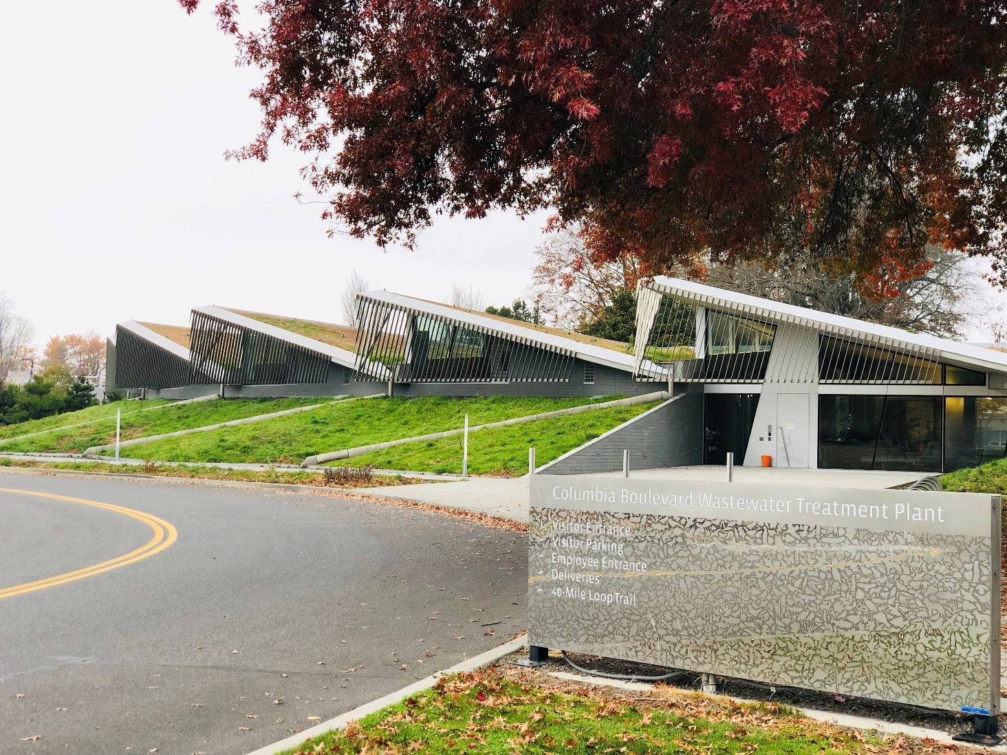

New Employee Orientation Check List

Treatment Pumping System Division (TPSD)

MANAGER/SUPERVISOR CONTACT INFO

* **Heather McKenna** 
  + - Cell (503) 850-8529

Text or Email to City address if running late or need time off unexpectedly

JOB DESCRIPTION AND PERFORMANCE

* Position: Tech II
* Reviews
* Annual

ORIENTATION

* **Access & Equipment**
  + Badges and Keys (coordinate with Elisa Rivera / Pat Coles – Admin Bldg)
  + Laptop & any other necessary computer accessories (Keisha Metayer)
  + Headset (order preferred style through Jen Flores. Valerie Menely has a flyer with available options)
* **Phone Setup – Options:** 
  + - Avaya softphone (digital phone software on your laptop) can be set up with a request to the Phone Coordinator, Keisha Metayer.
    - Desk phone instructions: [Technology and Phones | The City of Portland, Oregon (portlandoregon.gov)](https://www.portlandoregon.gov/bes/76286)
* **Outlook Email Signature Instructions**: <https://www.portlandoregon.gov/bes/78941>
* **Required Training** contact [BESTraining@portlandoregon.gov](mailto:BESTraining@portlandoregon.gov) to schedule trainings via MS Teams or in-person
  + Defensive Driver Safety (online) COMPLETE
  + Mandatory Reporting of Child Abuse (online) COMPLETE
  + Equity 101 NOT SCHEDULED YET TBD
  + HR 2.02 SCHEDULED FOR JAN 25
  + **New Employee Orientation** – Scheduled for January 9, 2024 10am – 12pm. In person at the Portland Building, room 206.
  + Oregon OSHA Wildfire Smoke Training Awareness (online)
  + Heat Illness Prevention Training (online)
  + Cybersecurity Awareness Training (online)
  + Manager/Supervisor training series (as applicable to position)
  + CBWTP Treatment Plant Campus tour (Admin bldg, Stores, and Processes). Coordinate with your supervisor on scheduling.

HR, BENEFITS, AND EMPLOYEE BEHAVIOR

* **HR Administrative Rules:** <https://www.portlandoregon.gov/bhr/61163>
* **Employees Behavior and Expectations:** <https://www.portlandoregon.gov/bhr/62373>
* **Ergonomic Evaluation:** desk / office chair evaluation (if needed). Contact: [besomfacilities@portlandoregon.gov](mailto:besomfacilities@portlandoregon.gov)

GENERAL INFORMATION

* **Timesheets & Type of Work Codes:** [Cost Centers, Time Entry, Type of Work (TOW) and GL Code Information | The City of Portland, Oregon (portlandoregon.gov)](https://www.portlandoregon.gov/bes/81899)
* **Inclement Weather Policy** -<https://www.portlandoregon.gov/bhr/article/621109>
* **Recurring meetings**
  + TPSD All Staff Meetings (2x per month: division meeting & racial literacy Q&A)
  + Check-in meetings with supervisor (weekly)
  + Chats with the Chief Engineer (several times a year via MS Teams)
  + Monthly Bureau Director Chats (via Zoom)
* **Safety:** [Safety | The City of Portland, Oregon (portlandoregon.gov)](https://www.portlandoregon.gov/bes/79860)

If you believe there is an emergency, call the Security number: 503-823-7777. In life-threatening emergencies, or when you need immediate police, fire, or medical assistance, make the following TWO calls: 9-1-1 first and then 503-823-7777.

* **Personal Protective Equipment (PPE / aka Safety Gear)** – raingear, rubber boots, safety glasses, hard hat, safety vest, ear plugs, safety hat decals - supplies available in Stores, if needed. Steel-toed boots required in construction areas. *(Contract Staff gear provided by Contract Employer)* More PPE info: [KM_C554e-20170130103832 (portlandoregon.gov)](https://www.portlandoregon.gov/bes/article/534915).

*Also, see* [*CBWTP Maps*](https://www.portlandoregon.gov/bes/81889) *for areas on CBWTP campus where PPE is required above and below ground.*

* **Vehicles** (reserve on Outlook, keys in Equipment closet & parked out the back door of CBWTP Columbia Building)
  + - **Chevy Volt:** OUTLOOK: BES Veh, WWT TPSD: Volt #191011
    - **Ford Escape:** OUTLOOK: BES Veh, WWT TPSD: Escape #211614
* **CBWTP Campus bicycles** – available to ride and return
* Onsite Fitness Center - Fill out waiver form before use (O&MG Admin).
* CBWTP Emergency Exit Route Map – route through CBWTP campus to back gate, if front access is blocked by train.

CITY, BUREAU, AND WORK GROUP OVERVIEW

* City of Portland – City Structure, Codes Code, Charter, and City Council: <https://www.portlandoregon.gov/employee/51116>
* BES Public Website: <https://www.portland.gov/bes/about>
* BES Videos

A River Renewed: <https://www.portlandoregon.gov/bes/article/466683>

City of Portland CSO Program 1991 – 2011: <https://www.portlandoregon.gov/bes/article/376695>

* Organizational Charts https://employees.portland.gov/bes/resource-library/organizational-charts
* BES Employee Manual: <https://www.portlandoregon.gov/bes/article/226222>
* BES Employee Website: <https://employees.portland.gov/bes>
* BES Office Locations & Campus Maps: [Campus & Building Maps | The City of Portland, Oregon (portlandoregon.gov)](https://www.portlandoregon.gov/bes/81889)
* TPSD Division IntrAnet: [Treatment and Pumping Systems Division (TPSD) | The City of Portland, Oregon (portlandoregon.gov)](https://www.portlandoregon.gov/bes/50528)
* Operations & Maintenance Group IntrAnet (sister group at CBWTP): <https://www.portlandoregon.gov/BES/65577>
  + OMG Phone List
  + Notes – What’s Happening, Weekend Update, Safety
  + Contractors Onsite, Ops Specs Special Assignments
* **CBWTP Phone List** <https://www.portlandoregon.gov/bes/article/509935>

**BES REFERENCE DOCUMENTS**

* BES Strategic Plan: <https://www.portland.gov/bes/documents/bes-strategic-plan-2018-2027/download>
* Continuity of Operations (COOP) Plan: <https://www.portlandoregon.gov/bes/76605>
* BES Essential Functions: describes each BES group’s role, including named positions in providing essential functions: <https://www.portlandoregon.gov/bes/81655>

**Project Management Software & Training:**

* + **Heron / eBuilder** (project management software):

<https://app.e-builder.net/www/index.aspx?ReturnUrl=%2f>

* + Contact [BESHeron@portlandoregon.gov](mailto:BESHeron@portlandoregon.gov) to get user access and request preliminary training. Contact Valerie Menely (Design)/Leah Bangert (Construction) to get membership access to specific projects, the access to the TPSD WW Engineering library.
  + Heron General Library (“How To…”) (00)
  + WW Engineering Library – TPSD Design & Construction Guidelines, Standard Forms, CSA DIv 00 & DIv 01 Specs)
  + **BlueBeam** (project technical review software):
    - Contact Corby Oliver / Daniel Jenkins for BlueBeam license and install.
    - Also, ask to be added to BES/PBOT BlueBeam users group (Outlook & MS Teams notifications of monthly forums, news, and trainings)
* **Adept** (record drawing management / as-built drawings): COMPLETE

**(**Derek and Jim can answer many questions about this)

* + Contact: John Ransone for one-on-one training.
  + <http://besweb1/synergis.webapp/#/login>
  + Login username and password match computer network login
* **SCADA** (wastewater asset management system) / iFix Historian access:
  + Submit a helpdesk ticket to have that person added to the AD group called : **BTS_SSLVPN_BES_automation.** Ticket will be routed to BES Business Systems Analyst. Contact: Anthony Givigliano.

PROJECT DELIVERY RESOURCES

* + **Capital Improvement Program:** <https://employees.portland.gov/bes/our-work/capital-improvement-program-cip>
  + **Capital Projects Delivery Manual**

[Capital Project Delivery Manual | The City of Portland, Oregon (portlandoregon.gov)](https://www.portlandoregon.gov/bes/80301)

And new location (partially migrated): <https://employees.portland.gov/bes/cip-manual>

TPSD Supplemental Delivery Guidance: [Project Delivery Supplemental Guidance | The City of Portland, Oregon (portlandoregon.gov)](https://www.portlandoregon.gov/bes/81884)

* + **Design 30, 60, 90% Review Check Lists**

<https://www.portlandoregon.gov/bes/article/638657>

* **Design Guidelines**

Heron WW Engineering Library: <https://app.e-builder.net/www/index.aspx?ReturnUrl=%2f>

Chapter 8 and Chapter 9

* + **Specifications** 
    - **CSI Template** (vertical construction, treatment plant and pump stations)

Div 0 and Div 1 – located in Heron (eBuilder) WW Engineering Library in Documents tab under Standard Specifications folder

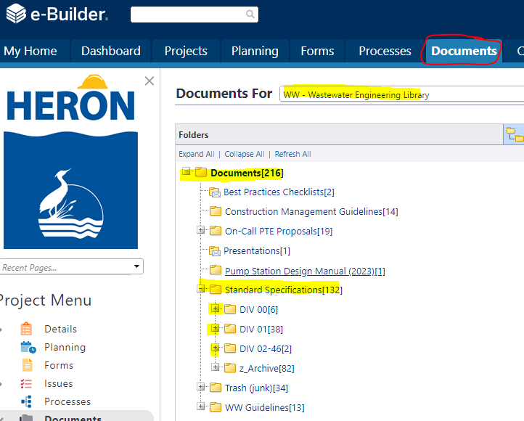

* + - **APWA Standard 10-division Template (aka ‘Burgundy Book’)** 
      * Used mostly for collection system projects and within the public right-of-way
      * [Construction Specifications | Portland.gov](https://www.portland.gov/transportation/engineering/construction-specifications)
* **Cost Estimating Tools -** <https://www.portlandoregon.gov/bes/80424>
* **Sewer assets, public easements, and property information** [www.Portlandmaps.com](http://www.Portlandmaps.com)

Manuals and Reference

* + **CBWTP Facilities Plan, TCWTP Facilities Plan, CBWTP Master Plan, RRM Project Delivery Lifecycle:** <https://www.portlandoregon.gov/BES/62080>

Read these:

* + **CBWTP and TCWTP Operations and Maintenance Plan** <http://www.portlandoregon.gov/bes/index.cfm?&c=70749>
  + **Pump Station Design Manual** <https://www.portland.gov/bes/documents/environmental-services-pump-station-manual/download>
  + **BES, City, and other manuals & resources** (public BES internet): Sewer Design, Stormwater Management, Source Control, Erosion Control, etc.: <https://www.portland.gov/bes/improvements/sewer-stormwater-technical-resources>